Name – Sayak Sen
Enrollment No – 2023CSB047
Assignment Sheet 2

Assignment 4

1.Retrieve the name of the students whose name starts with ‘S’ and contains ‘r’ as the second last character.
select name from students where name like 'S%r_';

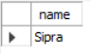

2. Retrieve the name of the youngest student(s) from the ‘CST’ department along with the total marks obtained by him (them).
select name,sum(marks) as total_marks from students
join crs_regd on students.rollno = crs_regd.crs_rollno
where deptcode = 'CSE' and bdate = (select max(bdate) from students where deptcode = 'CSE')
group by rollno;

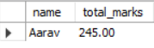

3. Find the age of all the students.
select rollno,name,TIMESTAMPDIFF(YEAR,bdate,CURDATE()) as age from students;

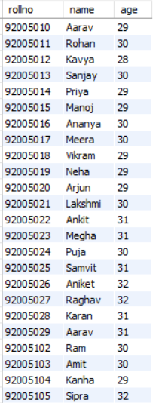

Assignment 5
1.Retrieve the name of the student(s) who obtained second highest marks in ‘DBMS’.
select rollno,name,marks from students
join crs_regd on students.rollno = crs_regd.crs_rollno
join crs_offrd on crs_offrd.crs_code = crs_regd.crs_cd
where crs_name = 'DBMS' and marks = (select max(marks) from crs_regd
join crs_offrd on crs_regd.crs_cd = crs_offrd.crs_code where crs_name = 'DBMS' and marks<(select max(marks) from crs_regd join crs_offrd on crs_regd.crs_cd = crs_offrd.crs_code where crs_name = 'DBMS'));

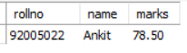
2.Find out the differences between highest and lowest marks obtained in each subject.
select crs_code,crs_name , max(marks)-min(marks) as diff_marks
from crs_regd
join crs_offrd on crs_regd.crs_cd = crs_offrd.crs_code
group by crs_code,crs_name;

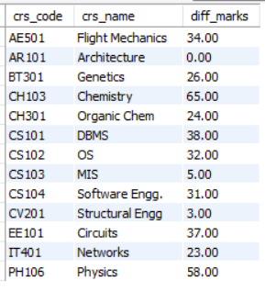
3.Assuming the existance of several interdepartmental courses, retrieve the name of the student(s) who is(are) studing under at least one faculty from each department.
SELECT name
FROM students
JOIN crs_regd ON students.rollno = crs_regd.crs_rollno
JOIN crs_offrd ON crs_regd.crs_cd = crs_offrd.crs_code
JOIN faculty ON crs_offrd.crs_fac_cd = faculty.fac_code
GROUP BY students.name
HAVING COUNT(DISTINCT faculty.fac_dept) = (SELECT COUNT(*) FROM depts);


4.Assuming the existance of several interdepartmental courses, retrieve the name of the student(s) who is(are) studing under the faculties only from his(their) own department.
select rollno,name from students
where rollno not in (select distinct rollno from crs_offrd, faculty, crs_regd, students
where crs_fac_cd=fac_code
AND crs_cd=crs_code
AND crs_rollno=rollno
AND fac_dept!=deptcode
GROUP BY rollno
UNION
(select rollno from students except (select distinct crs_rollno from crs_regd)));

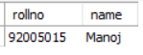

Assignment 6
1.Display the highest parent incomes, in descending order, for each
department excluding ‘ARCH’ such that only those highest parent incomes will appear that are below 12,000.
select name,parent_inc from students
where deptcode != 'ARC' and parent_inc < 12000
order by parent_inc desc;

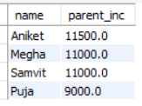
2. Retrieve the fifth highest parent income for hostel number 5.
select distinct s.parent_inc
from students as s
where s.hostel = 5 and
5 = (select count(distinct p.parent_inc) from students as p
where p.hostel = 5 and p.parent_inc >= s.parent_inc);

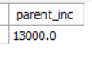
3.Find the roll number of the students from each department who obtained highest total marks in their own department.
select name,deptcode,rollno
from(select deptcode,rollno,name,sum(marks) as totalmarks
from students,crs_regd
where students.rollno=crs_regd.crs_rollno group by rollno) as tb1
where (deptcode,totalmarks) in (select deptcode,max(totalmarks) from (select deptcode,rollno,name,sum(marks) as totalmarks
from students,crs_regd
where students.rollno=crs_regd.crs_rollno group by rollno)as tb2 group by deptcode);
